**COVID-19 Simulation Documentation**

**Ngaruiya Peter Kuria**

**HB107/G/14706/21**

**Simulation And Modelling**

**Medical Engineering**

**COVID-19 SEIR Model Simulation Documentation**

**Introduction**

The MATLAB script simulates the spread of COVID-19 using a basic SEIR (Susceptible-Exposed-Infectious-Removed) compartmental model. The SEIR model is commonly used in epidemiology to understand the dynamics of infectious diseases. The model divides the population into four compartments: susceptible (S), exposed (E), infectious (I), and recovered (R).

**Model Equations**

The SEIR model is described by the following system of ordinary differential equations (ODEs):

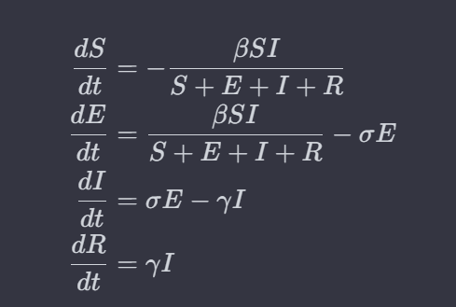

**Where;**

S is the number of susceptible individuals.

E is the number of exposed individuals (infected but not yet infectious).

I is the number of infectious individuals.

R is the number of recovered individuals.

β is the infection rate.

σ is the incubation rate.

γ is the recovery rate.

**Parameters;**

The model is initialized with the following parameters:

**Initial Conditions:**

*Io*​ (initial infected individuals) = 110

*Eo* (initial exposed individuals) = 0

*Ro* (initial recovered individuals) = 2

*So* (initial susceptible individuals) = Population of Kenya (approximately 53010000 million)

**Time Vector:**

t represents the time in days over a span of 5 years (365 * 5 days).

Model Parameters:

β (infection rate) = 0.3

σ (incubation rate) = 0.1

γ (recovery rate) = 0.1

**MATLAB Implementation**

The model is implemented using the ode45 ODE solver in MATLAB. The system of ODEs is defined in a function handle (ode) that takes the current time and state variables as inputs and returns the rate of change of each compartment.

The simulation is then carried out using the ode45 solver, and the results are plotted to visualize the dynamics of the disease spread over time.

**Running the Script**

To run the simulation, simply execute the MATLAB script. The script will display a plot showing the evolution of the susceptible, exposed, infectious, and recovered populations over the specified time period.

% Parameters

beta = 0.3; % infection rate

gamma = 0.1; % recovery rate

sigma = 0.1; % incubation rate

% Initial conditions

I0 = 110; % initial number of infected individuals

E0 = 0; % initial number of exposed individuals

R0 = 2; % initial number of recovered individuals

S0 = 53010000; % initial number of susceptible individuals (approximate population of Kenya)

% Time vector (days)

t = linspace(0, 365*5, 365*5);

% SEIR model differential equations

ode = @(t, y) [ -beta * y(1) * y(3) / sum(y); % dS/dt

beta * y(1) * y(3) / sum(y) - sigma * y(2); % dE/dt

sigma * y(2) - gamma * y(3); % dI/dt

gamma * y(3)]; % dR/dt

% Initial vector of state variables

y0 = [S0; E0; I0; R0];

% Solve the ODE system

[t, Y] = ode45(ode, t, y0);

% Plot the results

figure;

plot(t, Y(:,1), 'LineWidth', 2, 'DisplayName', 'Susceptible');

hold on;

plot(t, Y(:,2), 'LineWidth', 2, 'DisplayName', 'Exposed');

plot(t, Y(:,3), 'LineWidth', 2, 'DisplayName', 'Infected');

plot(t, Y(:,4), 'LineWidth', 2, 'DisplayName', 'Recovered');

xlabel('Days');

ylabel('Population');

title('SEIR Model for COVID-19 Simulation in Kenya for five years from 2nd April 2020');

legend('Location', 'best');

grid on;

hold off;

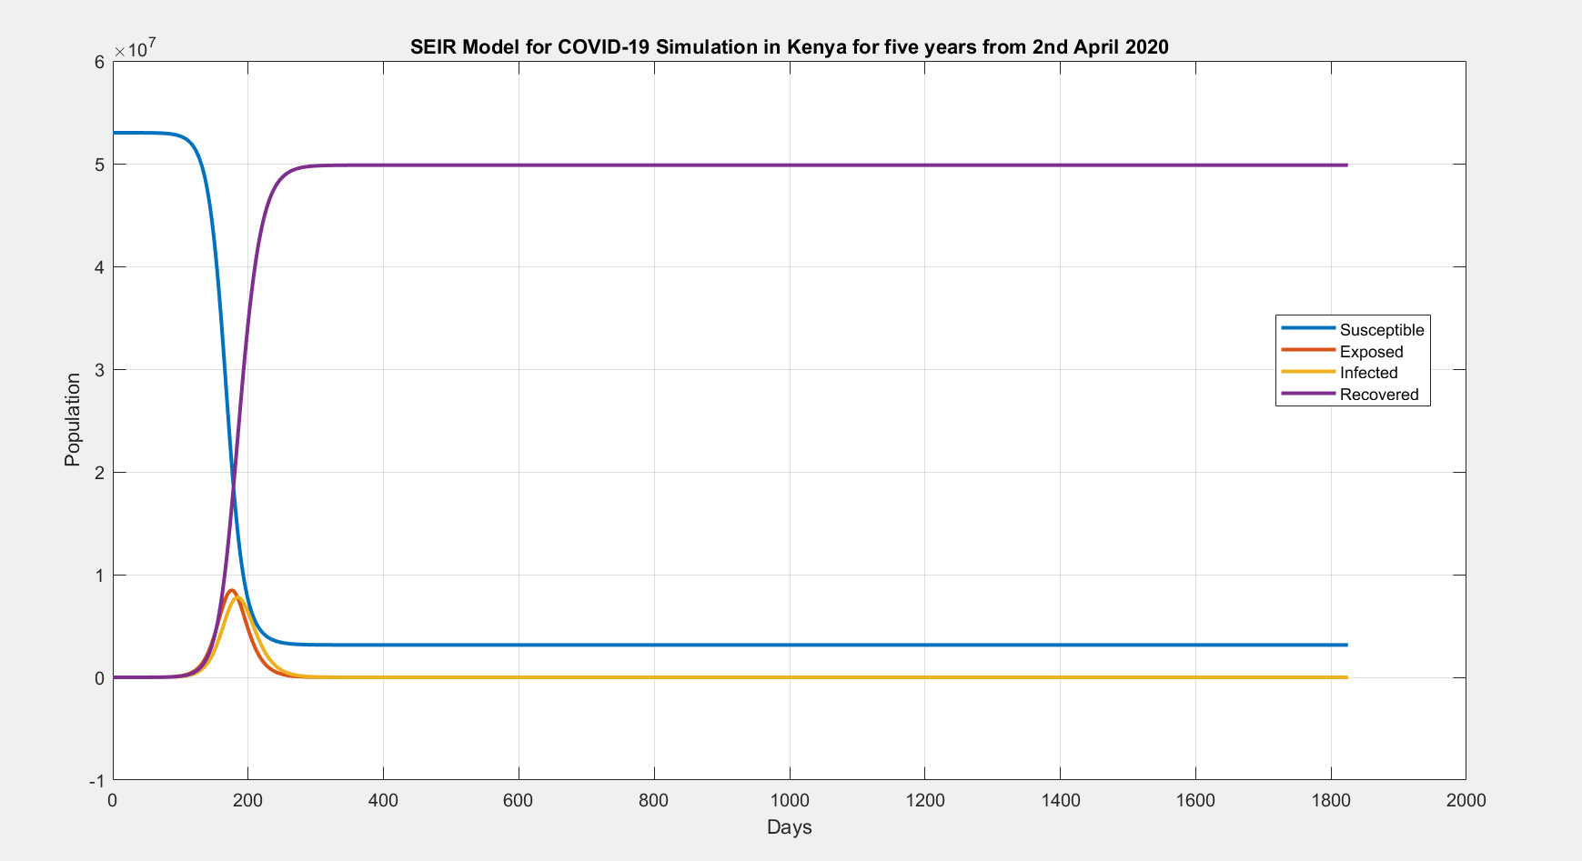

**Conclusion**

This script provides a basic framework for simulating the spread of COVID-19 using an SEIR model. The result is a graphical representation of the model that is composed of the susceptible, exposed, infected and populations.